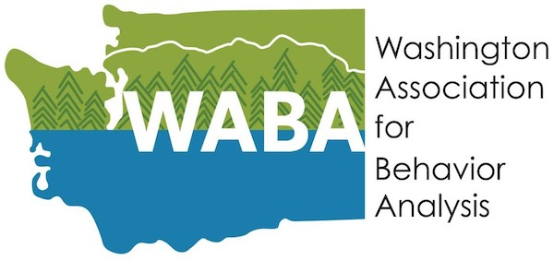

WABA 2023 Conference Poster Submission

Contact Information
Presenting Author’s Name:
Presenting Author’s Email:

Author Information
First Author (first and last): |  | Affiliation:
Second Author (first and last): |  | Affiliation:
Third Author (first and last): |  | Affiliation:
Fourth Author (first and last): |  | Affiliation:

Poster Information
Title:

Abstract (200-350 words):

For data-based posters, actual/sample data are attached: yes
(PDF or JPEG accepted)

Please complete the entire form and submit to conference@washingtonaba.org
by midnight on September 1st, 2023

By submitting this form, I attest that the content of this poster and the research it represents is valid and accurate and that I agree to present this poster on the date of the WABA Conference Poster Session.

Signed:____________________________ Name:_____________________________________

Incomplete forms will not be considered for approval.

